**Frequently Asked Questions** about Health Careers Summer Camp and Application Process

**What is the total cost of camp?**

The total cost of the camp is $125.00. All the Area Health Education Center (AHEC) camps are sponsored by AHECs and in some regions local health care systems. On average the camp costs $600.00 per student. Due to the generosity of our sponsors, students only pay the $125.00 non-refundable confirmation fee upon acceptance to camp. Financial assistance is available if needed.

**Who can attend camp?**

High school students entering 10th through recent graduates are eligible for the health careers camp. Students who have graduated high school are encouraged to contact their regional office to learn about camp counselor opportunities.

**Is this a day camp or an overnight camp?**

This camp is an overnight camp from Sunday to Wednesday evening. Students are required to attend the entire camp (start time to dismissal) and stay on campus overnight. Activities start in the morning and last into the evenings. Due to the camp schedule, no exceptions to the overnight stay are allowed.

**What is considered a complete application?**

A complete camp application is the Student Information Page (online), Student Personal Statement (online,) and TWO Teacher References (one from a Math or Science teacher and one from an English or Fine Arts teacher). Teacher reference forms are also online. A health occupations teacher can be one of the references. The student application will not be considered complete until all of the above forms are received by the AHEC regional office.

**Do the teacher *reference sheets* need to be included with the student portion of the application?**

No. Teacher references are completed online and are available on the NEWAHEC website at www.newahec.org. The student is responsible for directing teachers to the online form. The teacher references must be completed by the application due date. Teacher references are directly e-mailed to the camp director upon submission. As a student, remember to check back with your teacher’s to make sure they have completed the online form.

**What camp can I apply to?**

The camp you can apply to depends on the county in which you live or go to school. The following is the list of counties in the Northeastern region.

*Northeastern WI AHEC - Fox Valley Area Camp- Oshkosh* Counties eligible: Brown, Calumet Door, Fond Du Lac, Green Lake, Kewaunee, Manitowoc, Outagamie, Ozaukee, Sheboygan, Washington, Waupaca, Waushara and Winnebago.

**Can I apply to more than one camp in my Region?**

You may apply to more than one camp to increase your chances of being accepted, however; you will only be able to attend one camp.

**When will I know if I have been accepted to Camp?**

Students will be notified a *minimum* of three weeks after the application deadline date. You may contact the camp director if you have not been notified after the three week time period.

Please see Northeastern Wisconsin Area Health Education Center’s website for more information at [www.newahec.org](http://www.newahec.org)

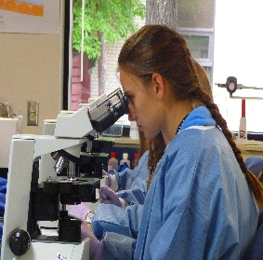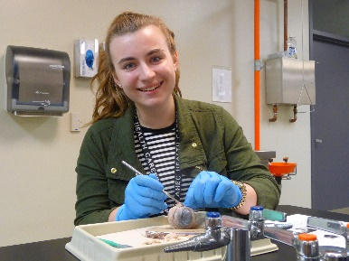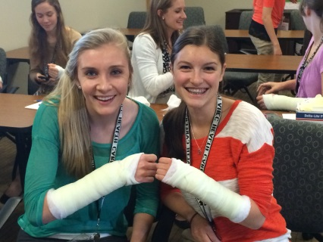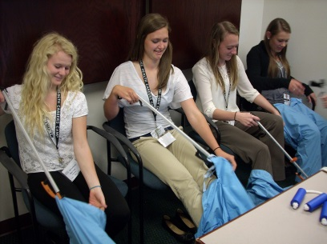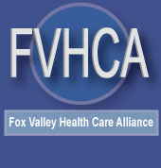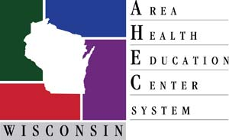

**Fox Valley Camp: June 14th – 17th**

**Summer 2020**

**Information available March 1st by contacting:**

* Northeastern Wisconsin Area Health Education Center (NEWAHEC) Phone: (920) 652-0238, E-mail: brendab@newahec.org
* NEWAHEC’s website—www.newahec.org
* Your School Counselor
* **Participate in hands-on activities and practice skills used in various healthcare professions**
* **Interact with physical therapists, nurses, x-ray techs, physician assistants, and many others!**
* **Learn about admission requirements, degree programs, and what you can do as a high school student to prepare for your future!**

**Discover your future career in healthcare at the 2020 Health Careers Camp!**

**Health**

**Careers Camp**